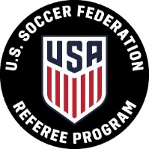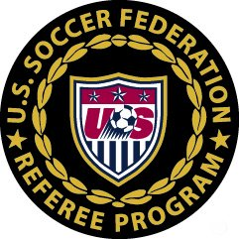**U.S. Soccer Federation Referee Program**

**Supplemental Referee Report**

**______________________________________________________________**

For instances of referee assault or referee abuse, complete and submit this form, along with a U.S. Soccer Referee Report, to the competition authorities (e.g., local league, tournament director, cup coordinator, etc.), State President with jurisdiction for the competition and State Referee Administrator. Please see U.S. Soccer Federation Policy 531-9 for more information about misconduct towards game officials.

|  |  |  |  |
| --- | --- | --- | --- |
| Home Team: |  | Score: |  |
| Away Team: |  | Score: |  |
| Game Location: |  |  |  |
| Game Date: | Click here to enter a date. |  |  |
| Association/League: |  |  |  |
| Division/Age Group: |  |  |  |

Statement:

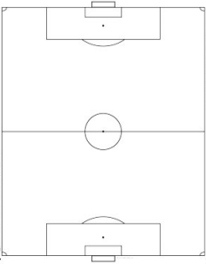

|  |  |  |
| --- | --- | --- |
| Name: |  |  |
| USSF ID Number: |  |  |
| Phone Number: |  |  |
| Email Address: |  |  |
| Report Date: | Click here to enter a date. |  |